1. what is the usage of different data structure in example

Data structures are fundamental tools in computer science and programming that allow efficient organization, storage, and retrieval of data. They provide different ways to represent and manipulate data based on specific requirements. Here are some examples of how different data structures are commonly used:

* + 1. Arrays: Arrays are used to store a fixed-size sequence of elements of the same type. They provide constant-time access to individual elements through indexing. Arrays are widely used for tasks such as sorting, searching, and dynamic programming algorithms.
    2. Linked Lists: Linked lists consist of nodes where each node contains a value and a reference to the next node. They are useful for dynamic data structures where elements can be efficiently inserted or deleted at any position. Linked lists are often used in implementations of stacks, queues, and graphs.
    3. Stacks: Stacks follow the Last-In-First-Out (LIFO) principle. They are used to store and retrieve elements in a specific order. Stacks are commonly used in applications involving function calls, expression evaluation, and backtracking algorithms.
    4. Queues: Queues follow the First-In-First-Out (FIFO) principle. They are used to manage elements in a specific order, where elements are inserted at the rear and removed from the front. Queues are commonly used in scheduling, resource allocation, and breadth-first search algorithms.
    5. Trees: Trees are hierarchical data structures consisting of nodes connected by edges. They are used to represent hierarchical relationships between elements. Trees have various applications, including binary search trees for efficient searching, AVL trees for balanced insertion and deletion, and B-trees for efficient disk-based storage.
    6. Graphs: Graphs consist of nodes connected by edges, representing relationships between elements. They are used to model complex relationships, such as social networks, road networks, and dependency networks. Graphs are crucial in graph algorithms like shortest path algorithms, minimum spanning tree algorithms, and graph traversal algorithms.
    7. Hash Tables: Hash tables, or hash maps, provide efficient key-value pair storage and retrieval. They use a hash function to map keys to array indices, allowing constant-time average case access. Hash tables are widely used in applications involving data caching, indexing, and lookup operations.

These are just a few examples of how different data structures are utilized. The choice of data structure depends on factors such as the type of data, the operations to be performed, memory constraints, and time complexity requirements.

1. how to decline and customize the priority in a queue implement an example

To define and customize the priority in a queue, you can use a priority queue data structure. Here's an example of how you can implement a priority queue in Python and customize the priority:

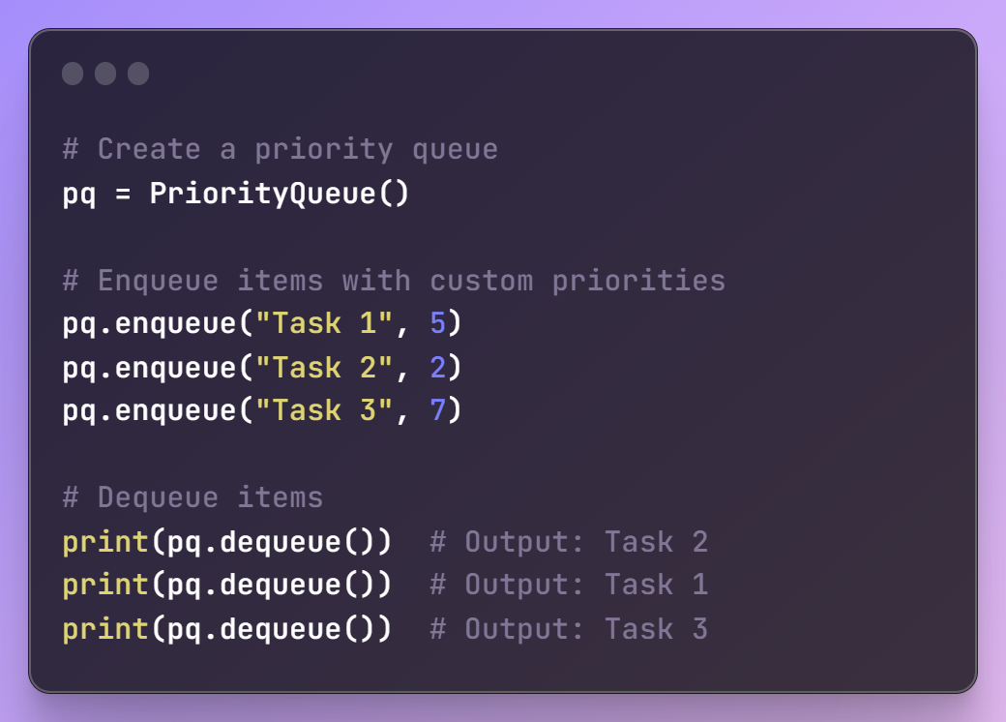

In this example, tasks are enqueued with different priorities, and then dequeued in order of their priority. The task with the lowest priority value (1) is dequeued first, followed by the tasks with priorities 2 and 3.

1. how to do queue of arrays

To create a queue of arrays, you can use a queue data structure where each element in the queue is an array. Here's an example of how you can implement a queue of arrays in Python:

from collections import deque

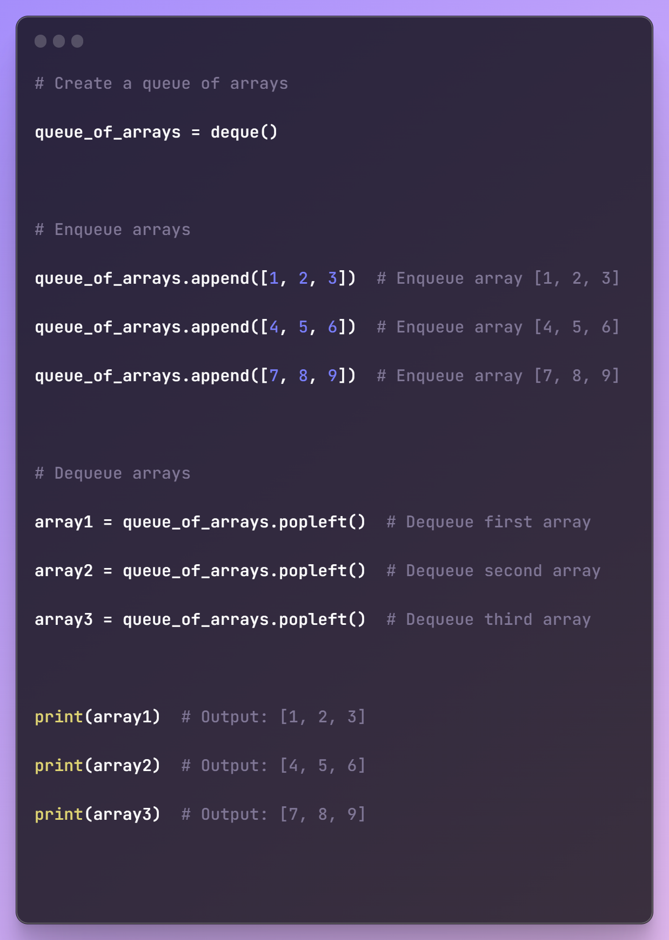

1. what is the library that implement graph and give example

There are several libraries available in Python that can be used to implement and work with graphs. One of the most commonly used libraries is NetworkX. NetworkX is a powerful library for the creation, manipulation, and study of the structure, dynamics, and functions of complex networks.

To use NetworkX, you need to first install it. You can install it using pip by running the following command:



Here's an example of how you can use the NetworkX library to implement a graph:

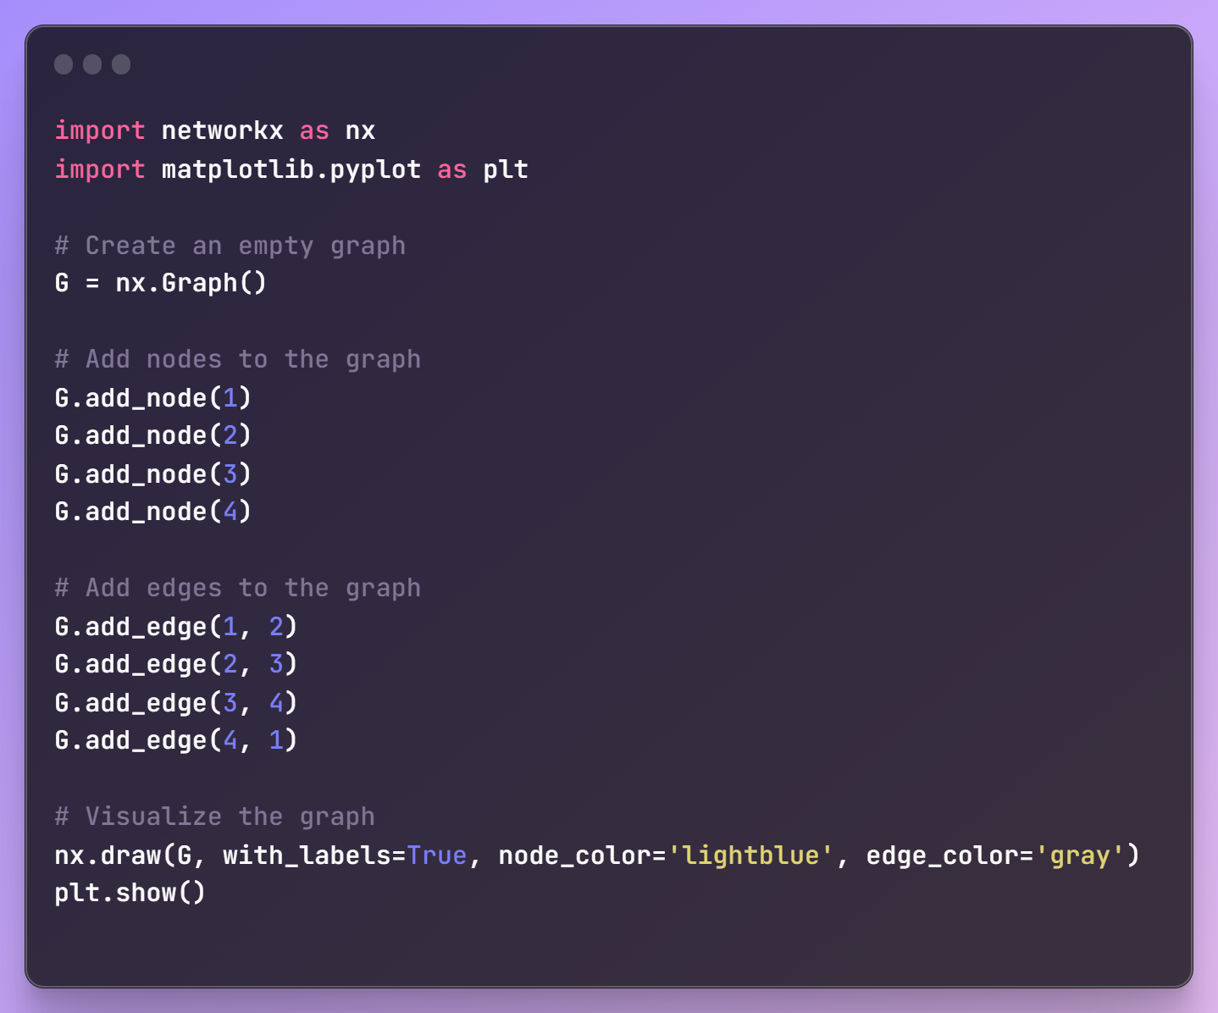  
In this example, we first import the NetworkX library as nx and the matplotlib.pyplot module for graph visualization. We create an empty graph using nx.Graph().

We then add nodes to the graph using add_node() method, specifying the node labels as arguments. In this case, we add nodes labeled 1, 2, 3, and 4.

Next, we add edges to the graph using add_edge() method, specifying the source and target nodes of each edge as arguments. In this case, we add edges between nodes 1-2, 2-3, 3-4, and 4-1, forming a cycle.

Finally, we visualize the graph using nx.draw() function, and plt.show() to display the graph.

NetworkX provides a wide range of functionalities for graph analysis, manipulation, and algorithms. You can perform operations such as finding shortest paths, calculating centrality measures, detecting communities, and much more using the NetworkX library.